ACTU 5841 Final Exam Write-Up

Name: Woon Sup Kim

UNI: wk2371

Date: May 12th 2022

**Question 2**

10-CV estimated error rate using sklearn’s pre-packaged cross_val_score resulted in an error rate of **0.61998**.

10-CV estimated error rate using a defined helper function resulted in an error rate of **0.60188**.

**Question 3**

[a] 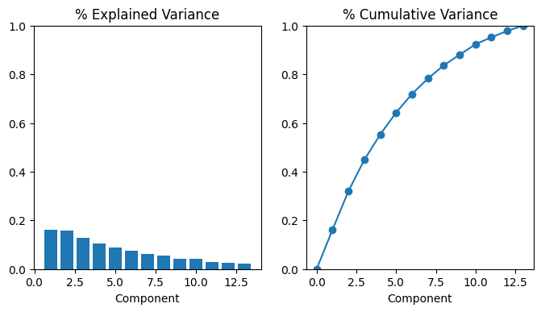

[b]

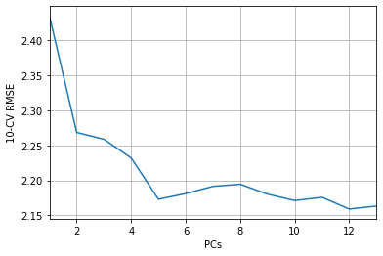

The optimal number of PCs to include in the PCR is 12 as it returned the lowest 10-CV RMS.

Alternatively, looking at the cumulated % of variance explained plot, one may find it desirable to select a minimum number of PCs that can sufficiently explain the variance in the data set. For example, 7 PCs explain 80% of the variance in this data set. The extra reduction in PCs may be desirable even if it costs some information of the data set.

Below are the coefficients of the PCs after fitting the model with 12 PCs. Each row is a PC.

PC_s

[[-3.82945293e-02 -1.06459373e-01 -9.93556736e-02 2.04309002e-01

-5.52529672e-02 -2.10848575e-01 -1.84345810e-01 -5.59222000e-01

-4.93120014e-01 -2.48923782e-01 -4.65112777e-01 -9.72633414e-02

1.02191622e-01]

[ 7.82242861e-02 -1.97747063e-01 -1.75788512e-01 -4.33439610e-01

-2.81397526e-01 5.21983071e-01 4.78283172e-01 -1.27739192e-01

-1.72179913e-01 -7.56572924e-02 -1.75876549e-01 2.66303947e-01

4.54122661e-02]

[ 3.36246343e-01 5.13559863e-01 5.99247148e-01 -6.25030957e-02

1.30461704e-01 2.19018140e-01 1.54610024e-01 -1.84206579e-01

-9.27376646e-02 1.85249008e-01 -2.07795344e-01 -2.26383614e-01

4.40928826e-03]

[ 6.32863149e-01 -3.21623966e-01 1.66448110e-01 -2.48884601e-01

3.98851355e-02 -1.78550199e-01 -3.96651875e-01 -3.46370708e-02

1.77353986e-01 2.39949629e-02 -1.40112653e-01 4.02201056e-01

-3.10300993e-02]

[-1.01316731e-01 -1.73654112e-01 -2.57122810e-01 -2.32887417e-02

6.28997982e-01 -6.98235245e-03 1.55944217e-01 -1.53045188e-01

-1.18188583e-02 6.04955469e-01 -2.20110197e-01 6.66614914e-02

-1.74622342e-01]

[-4.41962875e-02 7.69457208e-04 -4.92053821e-03 -1.29303290e-01

2.09860851e-01 -8.22677834e-02 4.75461111e-02 7.55516598e-03

9.03992197e-02 3.97987294e-02 2.09973751e-02 2.13675707e-02

9.57873606e-01]

[-3.83606852e-01 4.12482386e-01 1.65854669e-01 -5.54075718e-02

3.15757766e-02 -1.01124995e-01 -1.18847058e-01 3.11342431e-02

-2.23055439e-01 2.53411113e-02 -1.32399839e-02 7.57801348e-01

-3.12242721e-02]

[-8.95713084e-02 1.06221979e-01 -1.44977995e-02 -3.58860189e-01

5.28798112e-01 -1.06004183e-01 1.32822778e-01 -1.38744831e-02

2.11799366e-01 -6.72170333e-01 -1.11242817e-01 -6.52293095e-02

-1.72344346e-01]

[ 3.43839137e-01 -8.13099184e-02 -1.20576956e-02 6.21832568e-01

3.24975985e-01 2.30509559e-01 2.48561068e-01 -5.61834936e-03

-1.61625301e-01 -2.62145194e-01 2.92768949e-01 2.91191478e-01

4.93459325e-02]

[ 9.69327733e-02 -1.11091282e-01 7.99093838e-02 -3.92407386e-01

1.26576938e-01 -2.38842675e-01 2.64350628e-02 -2.00024489e-02

-6.18060523e-01 5.67285604e-02 5.78795106e-01 -1.44627159e-01

-5.08872637e-02]

[ 2.48890296e-01 1.66609115e-01 -2.44906674e-01 1.77087208e-02

2.41271458e-02 -1.50391419e-01 7.12404087e-02 7.18376024e-01

-3.64339564e-01 -1.79042962e-02 -4.09696119e-01 -6.17588732e-02

3.05645189e-02]

[-3.47399381e-01 -5.57485973e-01 6.06555536e-01 7.12019454e-02

1.13829134e-01 1.68960386e-01 -3.00504005e-02 3.02080632e-01

-1.46190006e-01 -5.45864597e-02 -1.88658109e-01 -4.34885429e-02

6.99795445e-03]]